Practice
LISTENING
I. Listen to the train announcement and answer the questions that follow:
1) The train that was announced is running from:
a) Mumbai-Secunderabad
b) Mumbai-Hyderabad
c) Hyderabad-Hussain Sagar
d) Mumbai-Hussain Sagar
2) The train is expected to arrive on platform number
a) 6 b) 5
c) 3 d) 2
3) The train is running late by
a) 20 min. b) 30 min.
c) 10 min. d) 40 min.
4) The train number is:
a) 5049 b) 6049
c) 6039 d) 4069
5) The train is expected to arrive at
a) 18 hrs 40 min b) 15 hrs 30 min
c) 14 hrs 30 min d) 16 hrs 20 min
II. Listen to the conversation and answer the following questions:
1) Where does the AP express go?
a) Rajasthan b) Jaipur
c) New Delhi d) Pink City
2) The foreigner wants to go to Jaipur. Where is the other person going?
a) Delhi b) Gujarat
c) Mumbai d) India
3) Which is the train suggested by the Indian?
a) Palace city b) Shatabdi
c) AP Express d) Palace on Wheels
4) What are the places suggested by the Indian to be visited by the foreigner?
a) Mumbai b) Jodhpur
c) Jaipur d) Rajasthan
5) “I appreciate your help”. Says the foreigner. What is the meaning of ‘appreciate’ in this context?
a) praiseworthy b) thankful
c) encouraged d) reject

SPEAKING
How to communicate with different people in different situations

Informal | Formal
Hey buddy! What’s up? | Good morning! How’re you?
Hi! Good to see you. | Hello! Nice to meet you.
How is it going? | Pleased to meet you.
It’s a pleasure to meet you. | How are you doing?
Long time no see. | How do you do?

Given below is a table which gives an example of how we greet different people depending on our closeness to them.
A friend | Hey! Whatsup?  
A Colleague | Hello! How’re you?  
A Superior | Good Morning Madam!  
An unknown person | Hello! I’m Sam. How do you do?  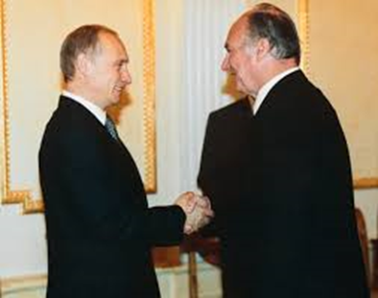
A huge gathering | A very pleasant morning to you all….  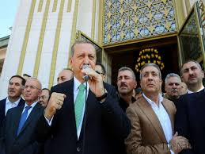

WRITING
Rajesh has joined the VIT University. On his day of joining, the supervisor asks him to say a few words about himself. The following conversation throws light on some of the common mistakes in spoken English. As the supervisor corrects Rajesh, we too learn the correct expressions.
Good Morning Sir! I am Rajesh. 40 years old. Me married. Have two children. One girl, one boy. Girl five years, boy eight years.
Good Rajesh, but it would be better if you say – I am 40 years old, and I am married. I have two children, a five year old girl and an eight year old boy.
Ok Sir, Thank you
Fine Rajesh, what is your work experience?
I fifteen years service sir. Worked in Vaniyambadi. My home town.
Oh fifteen years! Very good. But again, it will be good if you say, - I have put in fifteen years of service. I was working in my hometown, Vaniyambadi.

